

# Synopsis for Project

On

“DEPRESSION ANALYSIS USING COVOLUTIONARY NURAL NETWORKS”

# Submitted By

Mr.DAHALE AASHISH SHISHIRKANT [BE-B63] Ms.SHREYA THAKUR [BEA61]

Ms.GAUTAM THAKUR [BE]

# Guide

**Prof .Dr. R.V.BABAR**

### Year: 2020-21

DEPARTMENT OF ELECTRONICS & TELECOMMUNICATION ENGG.

SINHGAD INSTITUTE OF TECHNOLOGY, LONAVALA

**INTRODUCTION**

* Electroencephalogram (EEG) is a popular method for diagnosing various neurological diseases. Major Depressive Disorder (MDD) is a mental health disorder that can be diagnosed and treated by making use of EEG.
* G. One of the main challenges in using EEG to accurately identify depression is complexity and variation that exist in the EEG of a depressed person. Manually reading EEG and diagnosing depression is very challenging. An efficient computer aided method can be used for this task. Of the many methods that exists, a deep neural network method called Convolution Neural Networks (CNN) proved to be the most efficient.
* In this a multi-layer deep CNN algorithm is implemented to diagnose depression from EEG of patients. Depression is classified based on a severity index into mild, moderate and major classes. The accuracy, sensitivity and specificity were measured by varying various parameters of the proposed algorithm.

**LITERATURE SURVEY**

* Sudarshan et al. explored several nonlinear approaches for EEG centered detection of depression: Detrended Fluctuation Analysis (DFA), Fractal Dimension (FD), Higher Order Spectra (HOS), Largest Lyapunov Exponent (LLE), Recurrence Quantification Analysis (RQA), Hurst’s Exponent (H) and Sample Entropy (SampEnt). The obtained features are graded and organized in accordance with their importance by means of its t-value and was put into 5 distinct classifiers. It is reported that Support Vector Machine (SVM) provides top diagnostic assessment with a normal accuracy of around 98%. Furthermore, it was suggested to use Depression Diagnosis Index (DDI) which utilizes a mixture of the obtained non-linear features
* Yassin et al. likewise made use of SVM classifier for distinguishing normal and depression EEG signals having particular medical features obtained from EEG data. The attained EEG data were exposed to noise elimination in addition to feature ex-traction. Only the utmost important features were utilized for the testing and training of classifier structures: Support vector machine (SVM), Naïve Bayesian (NB) and Logistic regression (LR). 10-fold cross validation was used to check validation of the classifier which delivered performance metrics like test specificity, accuracy and sensitivity.

## PROBLEM STATEMENT

* It is difficult to achicheve result of depression level manually by doctors.
* it is time consuming and require doctors attaintion for long time

## OBJECTIVE

* To help doctors in getting correct diagnosis depression from EEG of patients Easily.
* Reduce time of diagnosis

## BLOCK DIAGRAM OF PROJECT

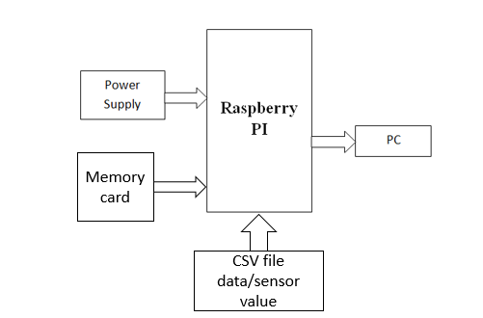

**Raspberry Pi**

* + Raspberry Pi is the name of a series of single-board computers made by the Raspberry Pi Foundation.
* The Raspberry Pi launched in 2012, and there have been several iterations and variations released since then. The original Pi had a single-core 700MHz CPU and just 256MB RAMA, and the latest model has a quad-core 1.4GHz CPU with 1GB RAM.
* All over the world, people use Raspberry Pi to learn programming skills, build hardware projects, do home automation, and even use them in industrial applications.
* The Raspberry Pi is a very cheap computer that runs Linux, but it also provides a set of GPIO (general purpose input/output) pins that allow you to control electronic components for physical computing and explore the Internet of Things (IoT).

**PYTHON-**

* Python works on different platforms (Windows, Mac, Linux, Raspberry Pi, etc).
* Python has a simple syntax similar to the English language. Python has syntax that allows developers to write programs with fewer lines than some other programming languages.
* Python runs on an interpreter system, meaning that code can be executed as soon as it is written.
* This means that prototyping can be very quick.
* Python can be treated in a procedural way, an object-oriented way or a functional way.

## METHODOLOGY

1. The design and implementation stage of the project, involved the Raspberry PI computer and programming
2. Electroencephalogram (EEG) can be utilized effectively diagnose depression in patients. In this study, a deep neural network approach called Convolution Neural Networks (CNN) was used to classify EEG of depressed patients based on severity into three classes: mild, moderate and major.
3. Raspberry Pi is a small computer on a single PCB The Raspberry Pi has a single-core 700MHz CPU and just 256MB RAMA, and the latest model has a quad-core 1.4GHz CPU with 1GB RAM.